ARTIST’S STATEMENT

In Jean-Luc Godard’s 1978 film ‘Comment Ça Va’ a historical image of the Portuguese revolution is deconstructed. Its purpose; to pose fundamental questions surrounding how an image is presented to a wider audience both visually and descriptively, “we began to think that with our pencils we had probably erased more than we had written, worse still, we erased even as though we were writing”.

The discussion as to how images are used to frame a cultural identity (in this case Portuguese) has been central to my practice. Bullfighting provided the initial hook, part of Portuguese identity, yet undergoing profound challenges in the last ten years.

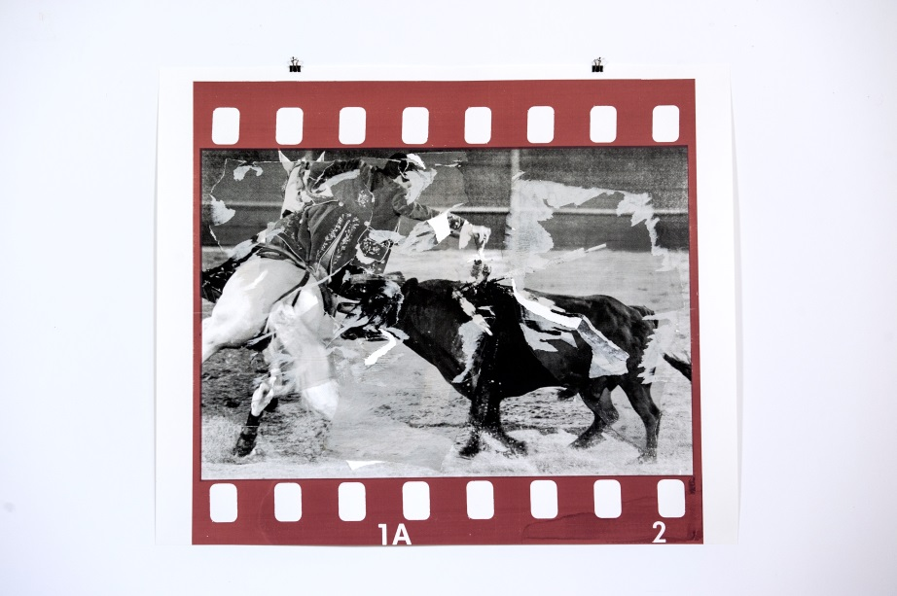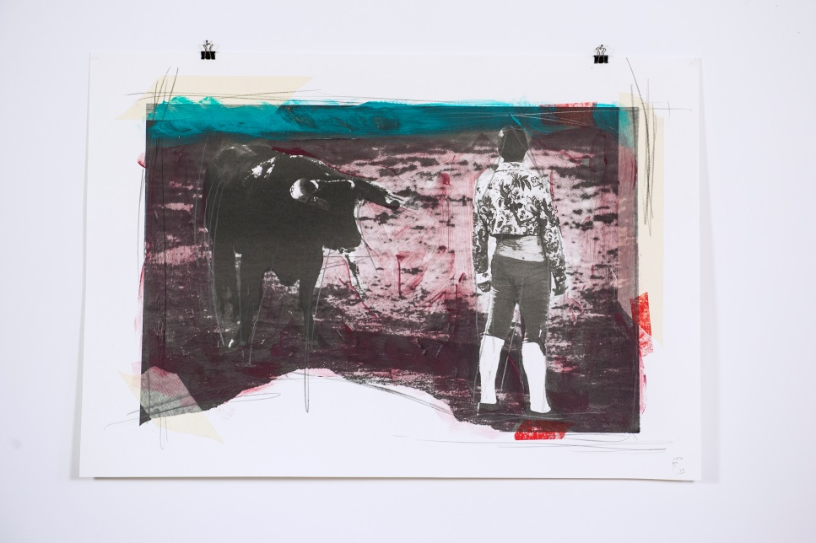

*Fuck You (one) Cultural Consequences (two)*

2015 2015

Monoprint Monoprint

47cm x 68 cm 69cm x 82cm

The narrative of this series of work was to engage in the discussion of shifting cultural identity. To widen this further, the appropriation of images from historical archives proved a turning point. From here the 2U5IT4NIA body of work, that forms the core of my degree show, emerged.

On 25 April 1974, Portugal overthrew Fascism in what was called the Carnation Revolution. 2U5IT4NIA (Lusitania, the Roman name for the region that is now Portugal) alludes to this date. The historical images used in these works were taken on that momentous day.

The aim of these works was to collectively address not only cultural identity but also to highlight how images are appropriated and often manipulated to produce a deliberate obfuscation of their original significance. To that end the process of décollage, in which different layers of an image are torn to reveal fragments of other layers, is pertinent as is their positioning.

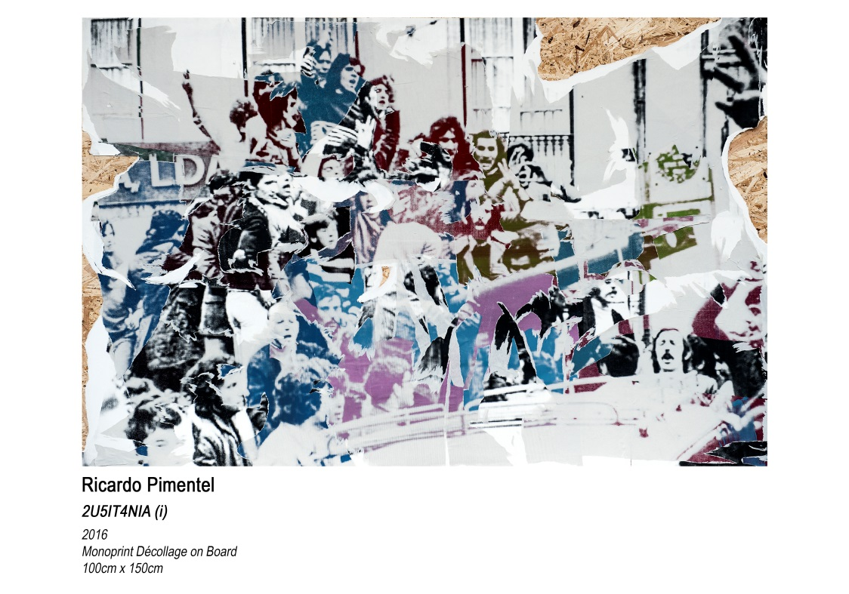

*2U5IT4NIA (i)*

2016

Monoprint Décollage on board

100cm x 150cm

However, part of the intended narrative is also to highlight our own roles in defining the image in the wider cultural conscious. Our actions, as identified in the Godard film, often erase or give an alternative significance to the original. The floor piece 2U5IT4NIA (ii), incorpoates elements of what Bourriaud coined *Relational Aesthetics*, ‘an art taking as its theoretical horizon the realm of human interactions’. Its siting centrally in the space forces the viewer to walk over the work, thereby becoming complicit in its obfuscation.

In a visual society, the appropriation of imagery and its palinoic presence is key. The remaining work alludes to this. Through the use of chemically distressed film stock, the lightboxes depict shifting cultural attitudes at the hands of advertisers and their advertising boards. Their siting randomly on the floor/low level is a deliberate attempt to reclaim their status from that objectification.

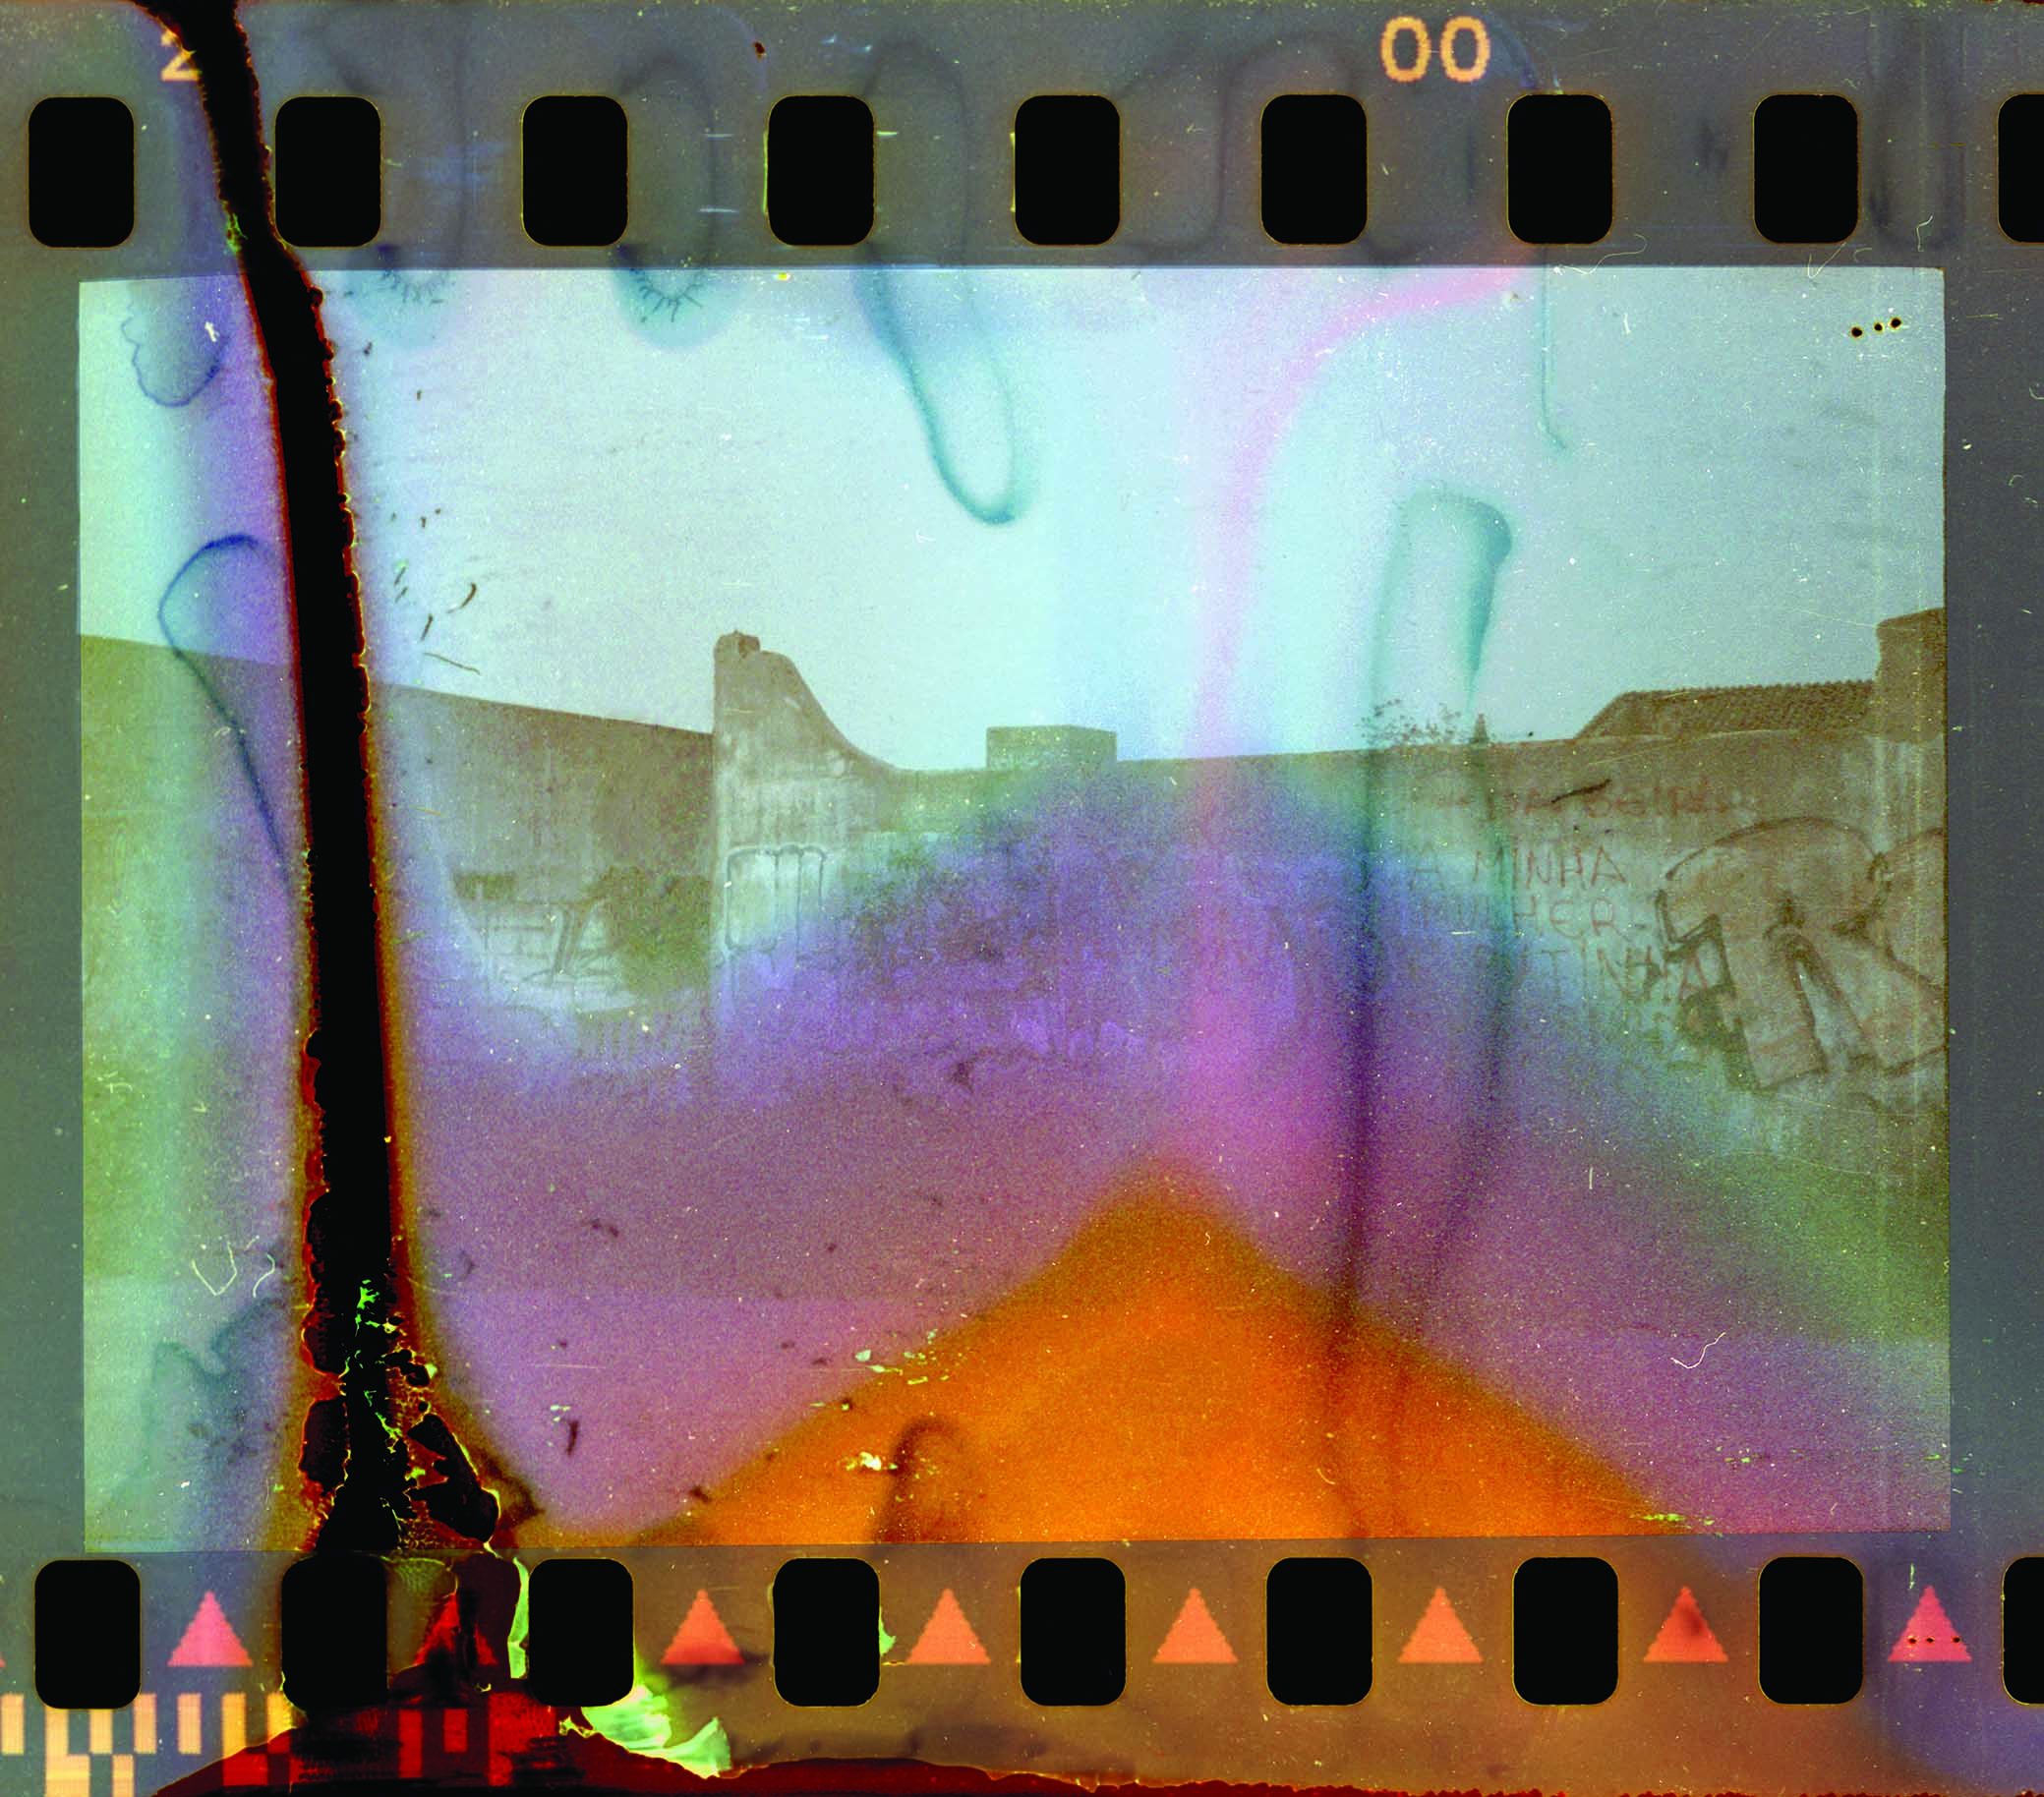

*2U5IT4NIA (vii)*

2016

Lightbox

31cm x 35cm

The significance of time as a factor in this cultural shift is reinforced by the use of pinhole cameras to create the multiple images printed on aluminium. Their size, forcing the viewer to take a closer look and reflect on the distortions.

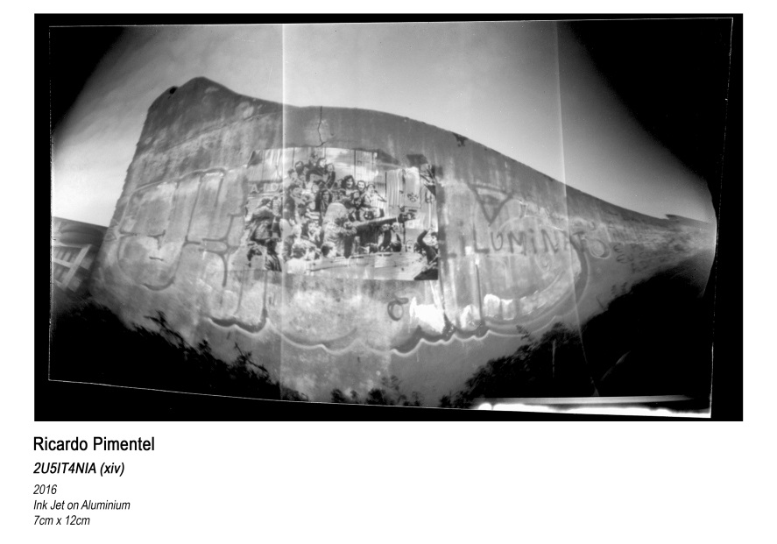

*2U5IT4NIA (xiv)*

2016

Inkjet on Aluminium

7cm x 12cm

That Portugal has recently been the recipient of a EU bailout adds extra poignancy to this installation. The 25 April, 1974 and the subsequent months was a unique period in Portuguese history and yet in the space of 42 years its significance has largely been forgotten.