|  |
| --- |
| The Presence of Absence |
| The Body as Political Tool |
| Ricardo Pimentel |

The Presence of Absence; The Body as Political Tool

Introduction: The Perspective of History

“As Gregor Samsa awoke one morning from uneasy dreams he found himself transformed in his bed into a gigantic insect”, Kafka (1916, p.9). With this opening line, Kafka introduced his unfortunate hero to the world. Metamorphosis, widely interpreted as an allegorical tale, explores the subjects of alienation, the grotesque and peoples’ responses to the other. The socio-political context in which this work sits is, I believe, enabled by the appropriation of a cockroach- like form and its use as a substitute for the human body.

The human body, its representation, appropriation and subsequent role, are integral to my own practice. It interests me primarily because its use allows the work to relate to the viewer in ways that are not predictable. How a viewer situates themselves, or is situated within the wider societal context, not only has infinite permutations, but is also not fixed. This variability and therefore unpredictability, I will argue, gives the works more urgency and the opportunity to explore aspects of contemporary society that demand attention.

Historically, the depiction and use of the body in contemporary art, has undergone a metamorphosis of its own. The physical body and its depiction as a purely figurative form has little currency in contemporary narrative since figurative art is considered primarily as an art for optical assimilation and one that largely reinforces established forms of artistic encounter, namely that of “passive spectatorial consumption”, Bishop (2012, p.275). Regarding the body solely as a physical form has further limitations, Sally O’Reilly emphasises this by stating that the body “is not simply the physical barrier of the skin, since this would overlook both the psychological sphere that exists beyond our basic corporeal boundaries and the reciprocal relationship between self and context” (2009, p.8), the implication being therefore that the use of body has an impact beyond the self, becoming a tool for engagement with wider social and political issues. These possibilities were dramatically explored in the early twentieth century with Dadaist performances, such as those of Hugo Ball at Cabaret Voltaire, which confronted the growing military mindset of Europe at the time. It was however only in the late 1960’s that the use of the body as a resource for social and political discourse became more widespread. Feminist art practice in the 1970’s, such as that of Judy Chicago’s ‘*The Dinner Party*’, set out to influence and transform cultural stereotypes associated with women1. Later, Cindy Sherman, through works such as the ‘*Untitled Film Stills’* 2,explored the question of contemporary identity. More recently though, artists have used the body in such a way that it acts as a conduit for active engagement between the artist and audience. The passivity of the audience is rejected and its participation considered a fundamental aspect of the work.

The topic of ‘the body in contemporary art’ is however a vast one. The body, its use and purpose, takes many different, often contradictory forms. The aim of this dissertation is to look more closely at the use of the body as a political tool, one that confronts established norms and the political hegemony of the society in which it was conceived and produced; In particular it looks at the work of artists that invoke its presence or its trace through appropriation and absence, rather than necessitating the incorporation of the actual physical form. This re-contextualisation of the physical form through appropriation and its invocation by other means has, I will argue later, a representational significance that goes beyond the art work itself, as it relies on the viewers’ experiences and their emotional engagement to complete the work. The support for the discussion and analysis of this will centre around the work of two artists, each with their own distinct traits, but each displaying common threads within the overall narrative of the absent body. In addition I will reflect on my own practice and how it both displays a parallelism and yet also a disjunct relationship with their work.

The artists I will consider are Santiago Sierra and Felix Gonzalez Torres. Both I believe to be extremely effective in using the *suggested* human body to confront established norms. Santiago Sierra primarily utilises the bodies of migrant workers to highlight their role in the underbelly of contemporary Capitalist society. The absent body features prominently in Felix Gonzalez-Torres’ most famous pieces too; in these he invites the audience to participate, reflect and empathise on both a political and emotional level. Although both artists’ mechanism for delivery is different, what they each present are both social and artistic critiques of Capitalism and its fallout on the marginalised sections of society. Social critiques in that they address political issues, artistic critiques in that they also challenge the existing hierarchical structure within the art world. They are not morally neutral and they force the viewer to take sides.

My own works will include an interpretative analysis of, ‘*The Sensational Case of Dr. Gillies*’ (Fig.1) and ‘*The Tooth Fairy Collection (four by five)*’ (Fig.2) and how they relate to the topic of the absent body.

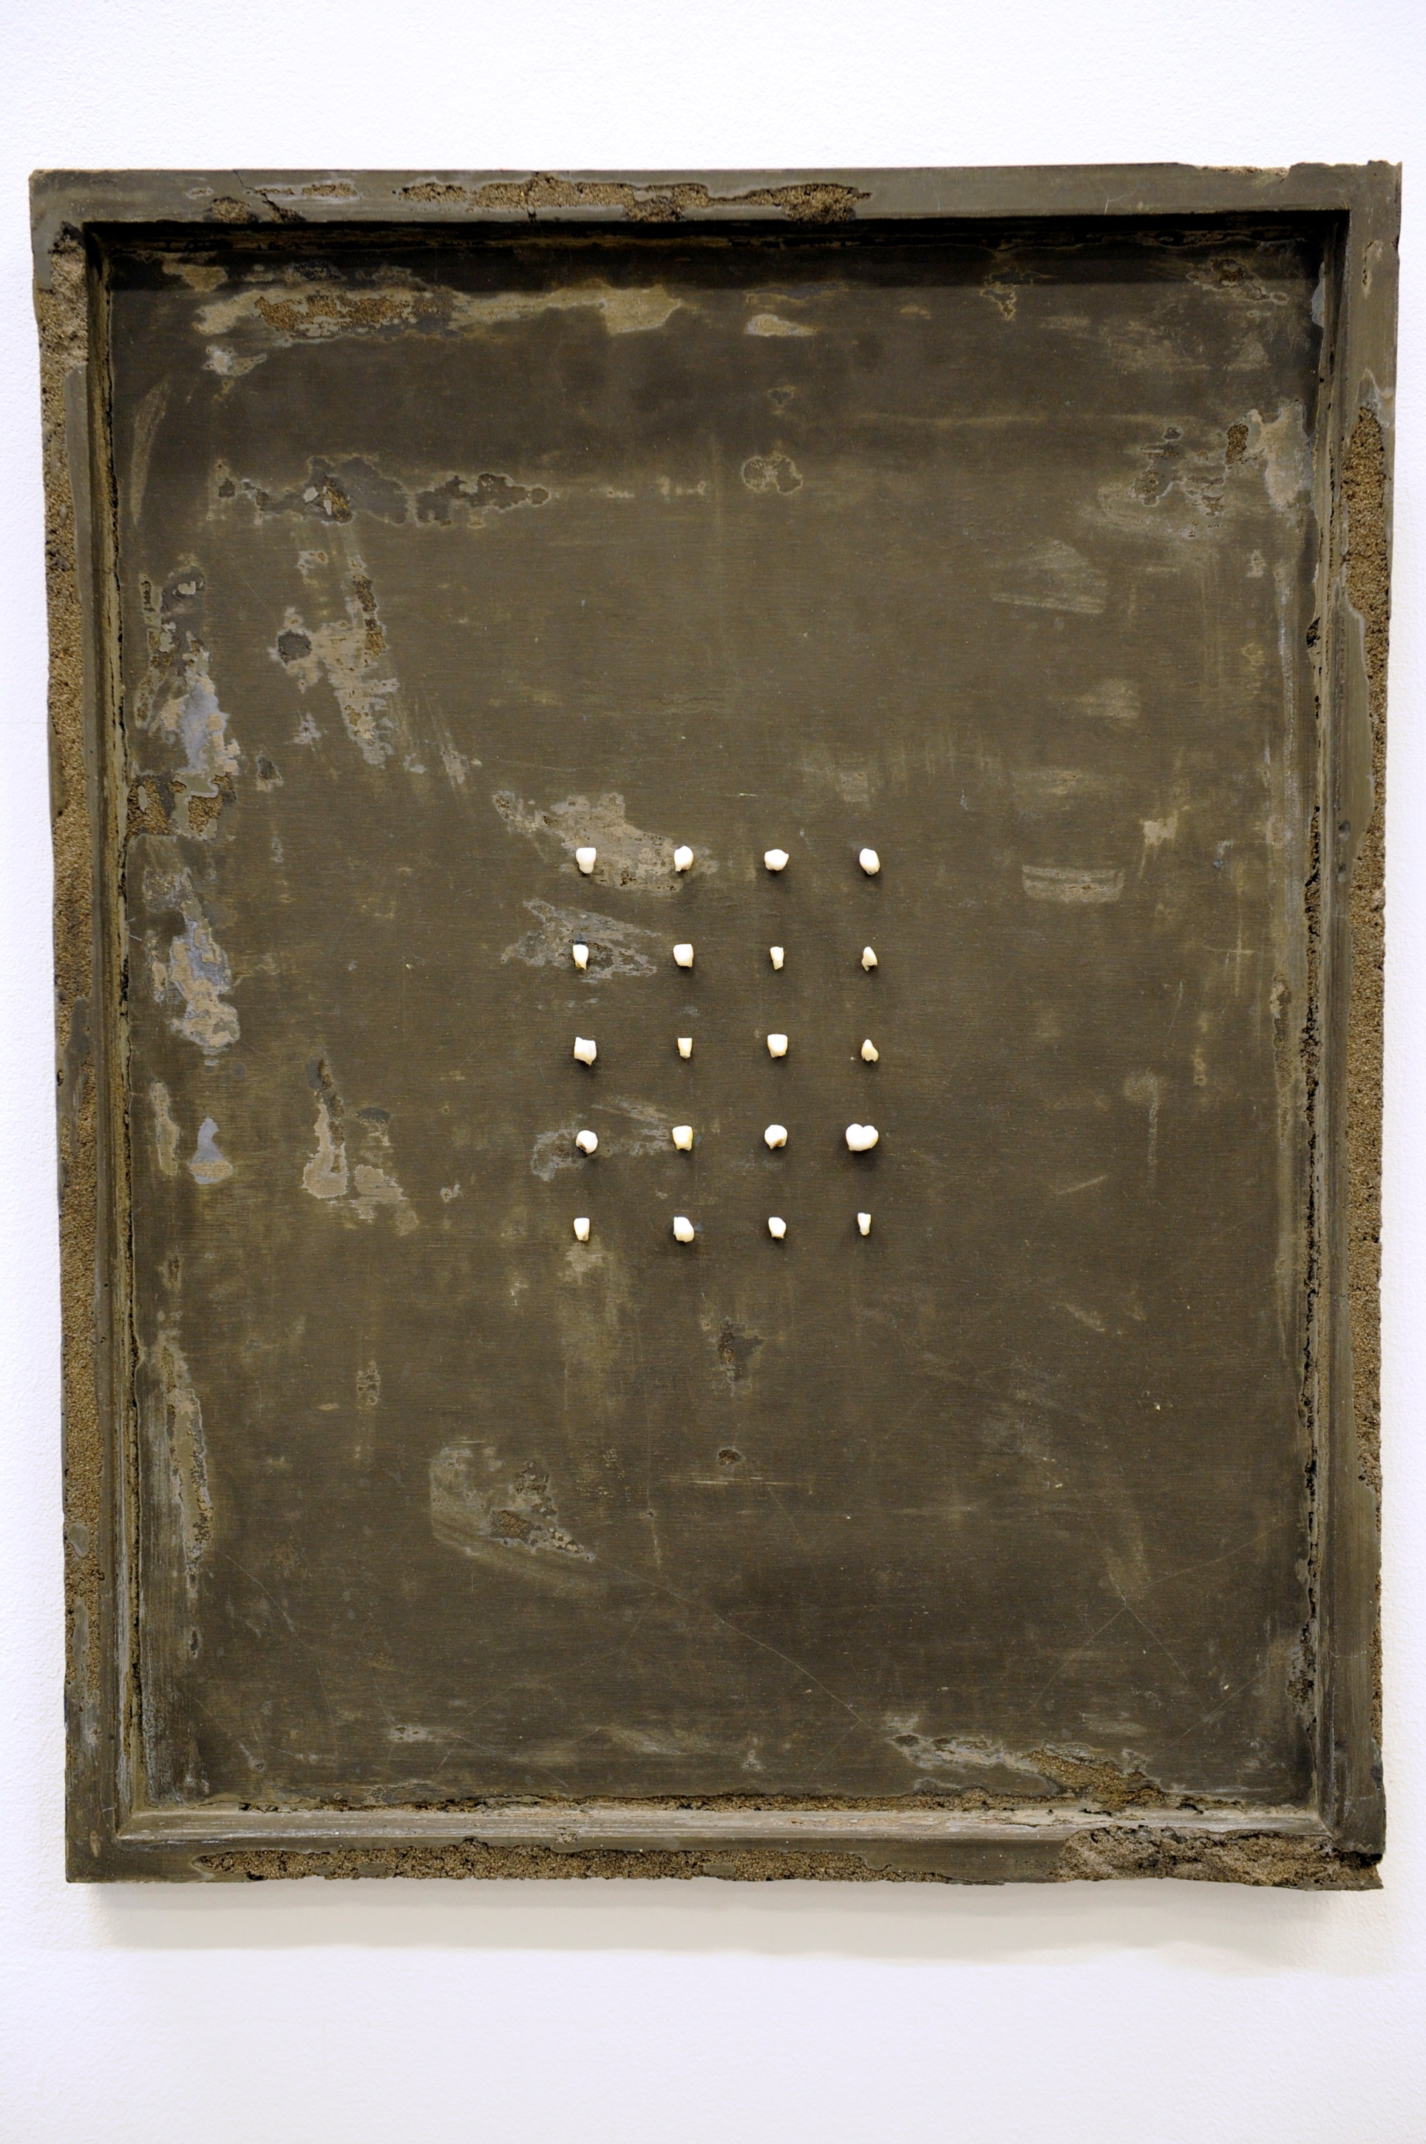

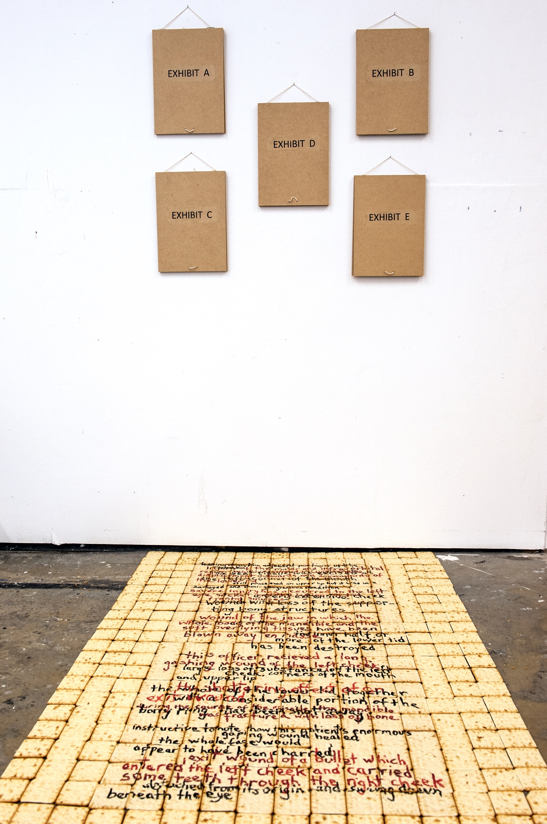

Fig.2: *The Tooth Fairy Collection*

*(four × five),* (2015)

Ricardo Pimentel

Fig.1: *The Sensational Case*

*of Dr. Gillies,* (2014)

Ricardo Pimentel

The former considers the utilisation of documentary evidence, taken from the archives of Dr. Gillies, a pioneering surgeon tasked with reconstructing soldiers’ faces during World War 1. The absent body here, represented through photographic documentation is appropriated for overtly political ends and contrasts with the second work in which, although the passage of time is also important, the response of the viewer is intended to centre around the conflict between abjection, the emotive response to the grotesque and nostalgia associated with memories of innocence and youth. The body’s role in this work is to be both simultaneously present and absent.

The Relational Perspective

To assimilate the situation in which we currently find art and in particular to appreciate the relevance of Sierra and Gonzalez-Torres within it, it is important to highlight the framework within which their work sits. Susan Sontag in ‘Against Interpretation and other Essays’ described how art had reached a stage in which an interpretative reading of the work by a critic is virtually a pre-requisite to the artistic experience. She also argued that this form of interpretation was predominantly reactionary and stifling, serving as it often did an existing elitist hegemony and that as a result “we have an obligation to overthrow any means of defending and justifying art which becomes particularly obtuse or onerous or insensitive to contemporary needs and practice” (2009, p.5). In other words, what Sontag was advocating, was not an end to all interpretation, but only that which leads to obscurification and a stifling of the emotive response.

Although penned in the 1960’s, Sontag’s essay is pertinent to today’s post-modernism. Increasingly, the relation between artist and viewer and the historical and social context in which the artwork is sited, is key. In this post-modernist environment, the artwork is not interpreted along established formalist criteria such as aesthetics. The rules, if there are any, are not the same as they were, in fact “those rules and categories are what the work of art itself is looking for” Lyotard (1982, p.1137). Therefore, although there still exists a plethora of critical interpretation, the focus is increasingly directed at the interaction and relation between artist and viewer. The interpretation is, as a consequence, intended to be more fluid and less directed. This post-modernist development, as relational art, has been observed and championed by Bourriaud (2002). “The possibility of a *relational art* (an art taking as its theoretical horizon the realm of human interactions and its social context, rather than the assertion of an independent and *private* symbolic space), points to a radical upheaval of the aesthetic, cultural and political goals introduced to modern art.”(*ibid*, p.14). In other words, there has been a shift in the dominance of the aesthetic judgement, the autonomy of the art object and in its place is the significance of the interaction between art work and viewer.

The move away from art necessarily having to have an aesthetic quality has historically had its critics. Clement Greenberg in particular (and later Michael Fried whom he mentored) was particularly sceptical of new directions that he described as ‘Kitsch’. Although specifically referring to the avant-garde, Greenberg asserted that it fell into the category of “vicarious experience and faked sensation” and “the epitome of all that is spurious in the life of our times” Greenberg (1939, p.40). According to Jennifer Doyle “For Greenberg, the term *Kitsch* signalled the recycling of feeling through popular culture at the expense of the new and authentic. Many of the works disparaged using this vocabulary (*vicarious*, *fake* and *kitsch*) fit easily under sentimentality’s umbrella” (2013, p.77). Latterly, Bishop (2004) and Martin (2007) who I will discuss further, have questioned the authenticity of relational aesthetics as an art form of social exchange as purported by Bourriaud, in particular his claims that relational aesthetics is truly a democratic experience, however what isn’t in question is that how we view art and relate to it has changed significantly.

The points above regarding interpretation, relational aesthetics and sentimentality are key to how we view the works that I will be discussing by Sierra and Gonzalez-Torres. I will argue though that rather than being an obstacle to their validity as serious art, these processes do in fact enhance their credentials. Throwing into this mix, a body (or the absence of one) makes the experience particularly powerful.

Coloured Candy

Felix Gonzalez-Torres’ work often occupied a space loaded with inter-subjectivity, the emotional and relational content key to the impact of the shared subjective state of the artist and viewers. Framed by their autobiographical nature and in particular by his homosexuality, his works were less a statement of his life but more an invitation to identify with it. Some of his more well-known works include “*Untitled” (Perfect Lovers)* (Fig.3), depicting two wall mounted clocks working in unison, “*Untitled”* (1991) (Fig.4) showing a black and white photograph of the artist’s recently shared double bed and , “*Untitled*” *(Portrait of Ross in L.A)* a pile of coloured sweets (Fig.5).

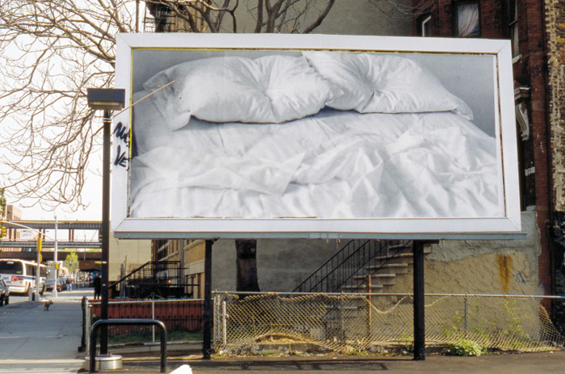



Fig.4: “*Untitled” (1991),*

(1991)

Felix Gonzalez-Torres

Fig.3: “*Untitled” (Perfect Lovers)*,(1991)

Felix Gonzalez-Torres

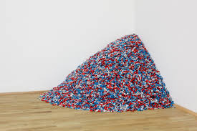

Fig.5: “*Untitled” (Portrait of Ross in L.A),*

(1991)

Felix Gonzalez-Torres

In each case the work depicts a body through its absence3 and in each case the narrative is one of love between two adults. However the absence of the body also signifies a loss, which in Torres’ world was a significant feature. To emphasis the point regarding the power of corporeal presence through absence I will concentrate on the latter work. Visually, *“Untitled” (Portrait of Ross in L.A)*, depicts a pile of sweets (coloured candy) placed against a corner of a gallery space. The pile of sweets initially weighs approximately 175lbs. This piece operates on several artistic and cultural levels. Passive objectivity however, is not intended to be one of them. Torres presents the viewer with the opportunity to take and consume the sweets thereby creating a situation in which a negotiation of the public space becomes necessary in order to engage with the work. The negotiation is intended to be fully democratic as, at this point, the artist has no control over the response or actions of the viewer. This fundamentally questions the established relationship between gallery/artist and viewer in which traditionally, the latter takes on a subservient role to the former; our association with authority is thereby exposed. The viewer is presented with choices, whether to simply admire the pile of sweets and reflect on its aesthetic quality (all that beautiful, colourful wrapping), or to reach out and take maybe one, two or as many sweets as our hands and pockets will support? Our social behaviour is therefore also laid bare for all to see. Bourriaud notes that “the candy pieces thus raise an ethical problem in an apparently anodyne form: our relationship to authority and the way museum guards use their power; our sense of moderation and the nature of our relationship to the work of art” (2002, p.57). The latter point in particular is pertinent to the question of the absent body addressed here. The weight of the work (175 lbs) is significant as it represents the weight of Torres’ partner Ross, when healthy. Ross suffered from and eventually died of an AIDS related illness in 1991. What Torres therefore successfully achieves is the transmogrification of physical presence to alluded presence, from single entity made of flesh and bone to one represented by thousands of consumable parts. The viewer is therefore confronted, not with the abject or the grotesque, but an invitation to empathise with a minority experiencing an uncomfortable moment in the spotlight.

This example appears to correspond with Bourriaud’s description of relational art as a form of social exchange and a possible counter to the service economies of contemporary Capitalist societies. Certainly the form of interaction is similar to examples he uses and Gonzalez-Torres was one of the artists cited by Bourriaud. However there are critics who argue that the value of this exchange is assumed rather than demonstrated and that rather than acting as a critique of contemporary capitalism it can be ‘read as a naïve mimesis or aestheticisation of novel forms of capitalist exploitation’ Martin (2007, p.371). Bishop (2004) and Kenning (2009) also question the assertions made by Bourriaud regarding relational aesthetics, ‘it begins to dovetail with an “experience economy”, the marketing strategy that seeks to replace goods and services with scripted and staged personal experiences’, Bishop (2004, p.52). In other words, these social interactions largely occur within the framework of institutions that are very much part of capitalism and that they are simply marketed cleverly to appear different. Bourriaud’s claim that relational aesthetics is completely democratic also comes under scrutiny. How can the exchange be completely democratic if the decision to engage can only be made by those attending the institution, the majority of which are likely to be members of the public already interested in art? This democracy is therefore predicated on the possession of a cultural capital favourable to art institutions.

However, these criticisms are more to do with the efficacy of relational aesthetics rather than Gonzales-Torres’ work. In other words, does relational aesthetics really achieve what it claims to? Not that Torres’ work fails to create empathy. The invitation to empathise with a homosexual minority is what made the work highly political when exhibited for the first time. It was a direct confrontation to American society’s reaction to the AIDS epidemic, particularly amongst conservative, evangelical Christian groups. AIDS was perceived by many as God’s retribution for the abomination that was the amoral lifestyle of the homosexual community. Torres’ work therefore, not only helped prevent the silencing of the gay voice at a time when homosexuality and the raising of issues surrounding it was under strain, but it was able to simultaneously provoke a sense of empathy with the viewer. A counter to the heteronormativity of mainstream culture. The representation of the body as sweets ensured that as the sweets are consumed, so the pile diminishes, as did Ross’ weight. The viewer is confronted with the conflicting emotions of the gradual loss of body and the pleasure of consumption, the absorption of sugar and the titillation of the taste buds. There is however, also an act of gestural complicity. The viewer is, by eating the sweet, partly responsible for the loss of weight, thereby perhaps acting as the virus and alluding to society’s ignorance of AIDS and its perceived disassociation from fact. In addition, the act of eating the sweet could also be compared with the taking of the Sacrament, ‘And as they were eating, Jesus took bread, and blessed *it*, and brake *it*, and gave *it* to the disciples, and said, Take this and eat; this is my body’. (The Gospel According to Matthew 26:26, The New English Bible). This queering is key to the subversive nature of Torres’ work.

I would argue that the absence of the physical body therefore has the potential to accentuate both the emotional and subversive power of a work. If one is to contrast Torres’ piece with David Wojnarowicz’s, *Untitled (Peter Hujar)* (Fig.6), it is clear that the subject matter documents a similar relationship between artist and lover dying of AIDS. Both are emotionally difficult for the viewer, both portray love and death within a society that at the time, was hostile.

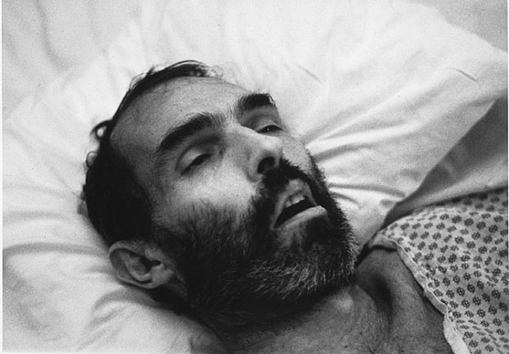

Fig.6: *Untitled (Peter Hujar),*

(1989)

David Wojnarowicz

They of course serve different purposes, Wojnarowicz’s piece acts more as a historical and emotional documentation of the effects of the disease on the individual and those around him. Those more likely to engage with it will already be familiar with the narrative of outrage and suffering. Torres’ piece on the other hand, in addition to acting as a tribute to Ross, succeeds in creating empathy with both him and the gay community. The viewer, drawn in through physical engagement and the participatory nature of the work, also experiences the loss.

Concrete Blocks and the Migrant Worker

Torres’ work utilises corporeal absence as a political tool, in that it creates a framework in which, amongst other things, the heteronormative prejudices imbedded in Western society can be challenged. The term ‘political’ pre-1960’s largely focussed on classical interpretations of class struggle, the left/right spectrum and what that entailed in terms of Socialist ideologies in comparison with Capitalist ones. By the 1960s and certainly from the 1970s onwards, particularly in Western societies, the term ‘political’ widened and was accepted as incorporating struggles for equalities within the society itself relating to sexual, racial and gender equality too. In other words, art associated with the identity of the individual became political. Central to that, was the use of the body as a vehicle for bringing these issues to the fore. It is therefore perhaps surprising that with this changing landscape of contemporary art practice, Santiago Sierra chooses to produce work that seemingly engages with, according to some critics, Marxist interpretations of the exchange value of labour. Marx argued that the ‘workers’ labour time is worth less to the capitalist than its subsequent exchange value in the form of a commodity produced by this labour’, Bishop (2004, p.71). Sierra takes this theory and extrapolates it to extremes in order to highlight this discrepancy. Some of Sierra’s key works include, ‘*250cm Line Tattooed on 6 Paid People’* (Fig:7) in which, as the title implies, six people (unemployed migrants) were paid to have a line permanently inked across their backs and ‘*7 forms measuring 600 x 60 x 60 cm constructed to be held horizontal to a wall*’ (Fig:8) where manual labourers were employed in a gallery space to support one end of a large beam.

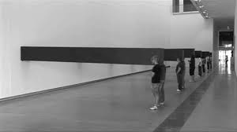

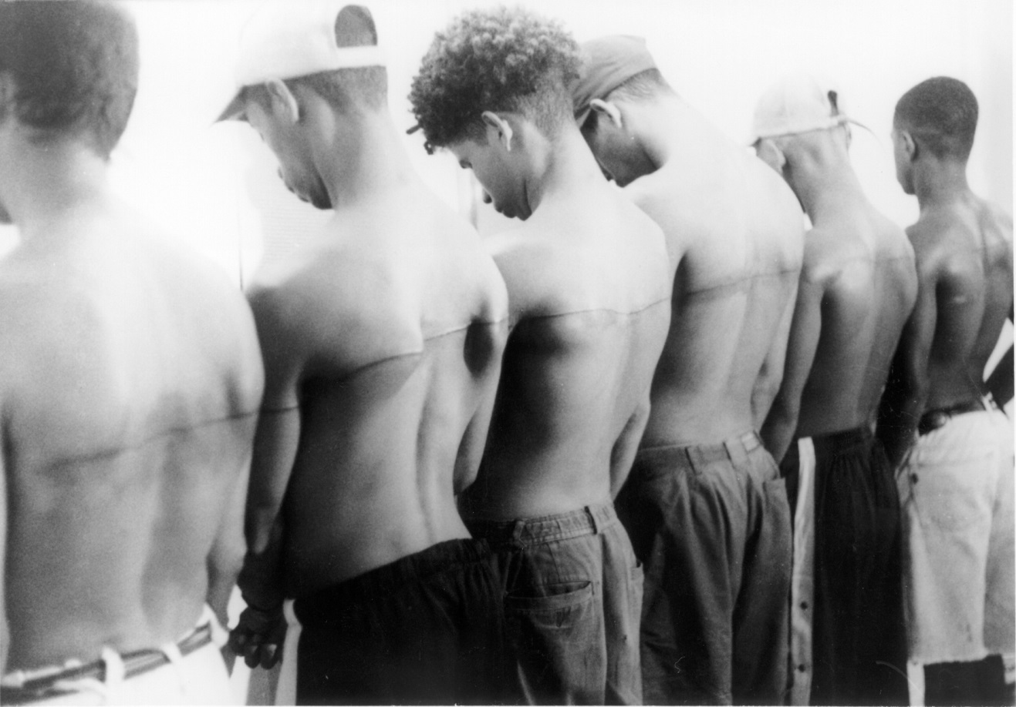

Fig.8: ‘*7 forms measuring 600 x 60 x 60 cm constructed to be held horizontal to a wall’*, (2010)

Santiago Sierra

Fig.7: ‘*250cm Line Tattooed on*

*6 Paid People’*, (1999)

Santiago Sierra

The work ‘*24 Blocks of concrete constantly moved during a day's work by paid workers*’ (Fig:9) involved, as the title suggests, 24 blocks of concrete, each weighing two tons, constantly being moved about a gallery space by a group of migrant workers in a seemingly pointless and repetitive exercise.

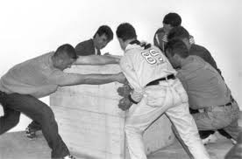

Fig.9: ‘*24 Blocks of concrete constantly moved during a day's work by paid workers’*, (1999)

Santiago Sierra

What viewers are presented with, is not the actual act of moving the concrete, but the marks left by the labourers in terms of the damage to the gallery floor, the remnants of their food packaging and the tools they used for the exercise. The fact that the migrant workers were remunerated with an amount equivalent to the low wage they could expect to receive for their labour outside the gallery space is critical to the piece’s narrative and a reference to Marx’s exchange value of labour. Everything has a price, the labour of the migrant, virtually worthless, the value of the commodity as art piece substantially more, both to the gallery and also to Sierra himself in the form of fees, royalties and further commissions. The viewer is also presented with the uncomfortable reality of the underbelly of the society we all inhabit. By reflecting on the pointless motion of the concrete blocks around the gallery, the viewer is knowingly complicit in the exploitation that has occurred and in particular art’s complicity in it. ‘Sierra makes present as art those whose systematic exclusion from art is a direct effect of the inequalities and consequent exploitation that art relies upon in its status as luxury commodity and cultural capital’ Kenning (2009). In addition Bishop comments, ‘Sierra creates a kind of ethnographic realism, in which the outcome or unfolding of his action forms an indexical trace of the economic and social reality of the place in which he works’ (2004, p.70).

The allusion to the corporeal presence in this work, I argue, is its strength. As already mentioned, the aim of Sierra’s work is to provoke discomfort in the viewer, more specifically a relational antagonism than the wider relational aesthetic. With most of his works, the economic migrant is visible and according to both Bishop (2004) and Kenning (2009) this is enables the viewer to assert that ‘this is not me’ thereby also exposing art’s limitations as a force for political change, which may well be the case. However by enabling the viewer to erect a barrier to empathy through non-identification with the migrant (i.e. I am clearly not the same as them) it facilitates disassociation. ‘*24 Blocks of concrete constantly moved during a day's work by paid workers*’ overcomes this by removing the workers from the final presentation of the work and the viewer’s disassociation is less likely. In other words, with the removal of obvious points of comparison between viewer and migrant, such as appearance, the viewer is less likely to disassociate themselves from feelings of empathy.

Sierra’s work in general does, though, attract criticism primarily because of the exploitation of the labourers. Sierra appears to be deploying the very practices and contradictions that he is highlighting. In addition, rather than attempting to provide answers, Sierra is merely ‘reproducing the methodologies of economic exploitation as configured by the current capitalist system’, Rosero (2013, p.100). However, although these criticisms appear well founded, I think they miss the point. Rosero argues that much of his work, of which this piece conforms with, deals with the ‘promise of freedom through work’ (*ibid*, p.102). In a capitalist society, the belief that personal wealth can be generated through work is key. Sierra highlights the fact that the migrant labourer is not free, both because he has little option but to accept the demeaning work, but even after doing it, his prospects both socially and economically remain unchanged, in fact, on the contrary it contributes to his ‘subjectification and domination’ (*ibid*, p.104). In contrast Sierra’s exertions, restricted to the organisation of the piece, its theoretical underpinning and the subsequent decisions regarding its dissemination, are considered of value. Therefore ‘freedom is conditioned by the desires and necessities of the context that surrounds the individual, and in this manner, limited to the expectations and perverse needs of an outside’ (*ibid*, p.107) The power of Sierra’s work comes, I would argue, through the deliberate use of the human body and the subjectivity associated with it, as an artistic and political vehicle. Their inclusion forces the relational content already described, to be at the forefront of the viewer/artist interaction. However, the absence of the visible body in ‘*24 Blocks of concrete constantly moved during a day's work by paid workers*’ reinforces the point that it can be equally if not more powerful to allude to this presence.

Own Practice

Sierra’s and Gonzalez-Torres’ works both manage to use the absence of the body for both artistic and political ends. That art can and should be political and that it can encompass both artist and viewer has a number of theoretical points of reference. In Roland Barthes’ ‘Death of the Author’he concludes with “The birth of the reader must be at the cost of the death of the Author”, Barthes (1968), a statement that suggests that although the origin of a work (in Barthes’ case literary) rests with the author, its destination lies with the reader. I have argued that the intention of both Sierra and Gonzalez-Torres is to create an intersubjective dialogue, nevertheless, although that is their intention, it rests with the viewer to successfully accomplish this aim. Without the viewers’ interventions or engagement, the works’ impact lessen. Another idea that is key, resides with the situationist theories of Guy Debord. In his ‘Society of the Spectacle’ Debord rallies against the alienating effects of Capitalism. Capitalist society, he argues, has become such that our experiences as individuals have become mediated through images (the spectacle) and as a consequence the bonds that hold together our society have become fractured and critical thought repressed; “The spectacle is the nightmare of imprisoned modern society which ultimately expresses nothing more than its desire to sleep. The spectacle is the guardian of sleep”, Debord (2010, *p.*21).

In many ways these theories and the work of the artists mentioned overlap with my own artistic practice. ‘*The Sensational Case of Dr. Gillies*’ is a two-part political piece born out of my belief that within current British society there is a growing sanitisation of the horrors of war, as, absent from much of the imagery presented to the public, is the pain and suffering that war engenders. I was struck in particular by two instances in the last twelve months. The first being ‘Blood Swept Lands and Seas of Red’, the poppy installation at The Tower of London by artists Paul Cummins and Tom Piper (Fig.10) in which each body of the fallen is represented by a ceramic poppy.

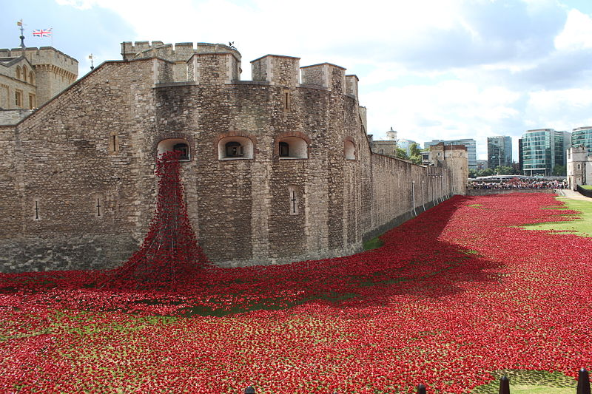

Fig.10: *Blood Swept Lands and Seas of Red,*

(2014)

Paul Cummins and Tom Piper

It is interesting to note, that here too the figurative representation of the body is alluded to by other means. Instead of the coloured sweets used by Gonzalez-Torres we have poppies. However unlike the works of Gonzalez-Torres and Sierra discussed in detail earlier, the absent body here, I believe, significantly undermines the work. The substantive reason being that in this case the beauty of the work is so startling and its scale so vast, that it succeeds in detracting the viewer from the intended significance; the huge loss of life. Whether this was intentional is open to debate.

The installation commissioned to commemorate the outbreak of the First World War, succeeded in my mind simply to carpet the Tower’s moat with a veneer of artificial poignancy. This opinion was shared by some critics, Jonathan Jones writing in the Guardian Newspaper gave the following description: “the installation at the Tower is spuriously beautiful: it allows us to mourn without seeing anything to cause visceral distress. It muffles the terrible facts. It is so tasteful, so decorous” (2014). The second case concerned the Supermarket chain Sainsbury’s 2014 Christmas advertisement (Sainsbury’s, 2014). A reference to the Christmas Eve truces that occurred at several points along the Western Front in 1914 and the near mythical status of a football match between Allied and German forces. The advertisement ends with the line “Christmas is for sharing”. The appropriation of World War 1 to essentially increase grocery sales, coupled with the advertisement’s failure to even allude to horror, let alone to depict any, constituted at best, a denial of what conditions were like and at worse a deliberate attempt to erase the horror of war from the public consciousness. ‘What passing bells for these who die as cattle?’ (Owen, 1917). My piece is therefore directed at confronting these two issues, commercialisation of war and the glossing over of its horrors. The aim was also to engender a situation in which the viewer is not only confronted with the commercialisation yet also complicit with the erasure of the horror.4 The dichotomy in the images I use is intended to shock and also to provoke a sense of distaste, but the principal point is to raise the question, ‘is the use of these images for commercial reasons any different to that which already exists?’ The Sainsbury’s advertisement is endorsed by the Royal British Legion, mine isn’t, which poses the subsequent question of whether endorsement by an established/establishment body makes the commercialisation more acceptable? The use of well-known faces/institutions to sell products of any sort is a well-established technique for raising the profile of a product thereby hopefully increasing sales, so one would assume that the use of the Royal British Legion was a conscious decision to secure an increased profile and acceptance.

The images therefore serve to question the morality of using war for commercial purposes. The additional dilemma for the viewer however is that in order to reach the exhibits he/she will need to walk over and thereby crush a carpet of biscuits on the floor painted with quotes taken from Dr. Gillies’ text (Fig.11 & 12), for example “the whole body of the mandible and the soft overlying tissues have been blown away *en masse*” (1920, p.168).

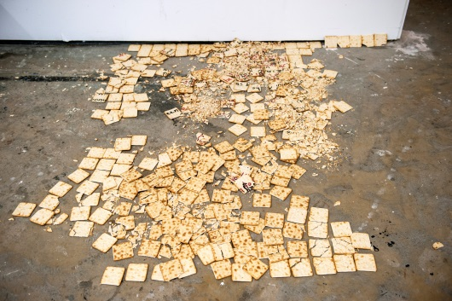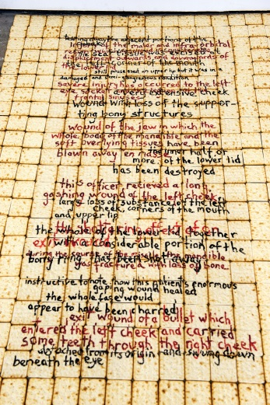

Fig.12: *The Sensational Case of*

*Dr. Gillies (detail),* (2014)

Ricardo Pimentel

Fig.11: *The Sensational Case of*

*Dr. Gillies (detail),* (2014)

Ricardo Pimentel

This is a significant aspect of the piece. In many ways the act is similar to the taking of the sweets in Gonzalez-Torres’ work in that it undermines convention by inviting the viewer to transgress the institutionalised structure of the artistic space. The viewer is not expected to be a passive spectator, the destruction of part of the piece is intended as a subversive act. Just as those taking Gonzalez-Torres’ sweets are complicit with the weight loss, here the viewer becomes complicit in the erasure of the memory of the pain and suffering. The trace of the body lies in the illegible remains of crushed biscuits – a deliberate act of obscurification. I would go further and argue that just as the viewers’ act of crushing is a deliberate act (as the outcome of walking over them is never in doubt), so too is the sanitisation of war by institutions and Government. Susan Sontag, although referring primarily to the effects of war photography, identified this phenomenon quite clearly when she stated that, as a result of the images coming out of the Vietnam war fuelling anti-war sentiment in the general public, the narrative needed to be controlled and that “since then, censorship – the most extensive kind, self-censorship, as well as censorship imposed by the military – has found a large and influential number of apologists” (2003, p.58). In other words, despite living in a democratic society, we have reached a point in which censorship, including self-censorship, is regarded as necessary. This criticism relating to controlled narrative and self-censorship can be labelled at the ‘Blood Swept Lands and Seas of Red’ installation. Its siting at the Tower of London (one of the Historic Royal Palaces) and subsequent high profile visits by several members of the Royal Family, ensured that this narrative of World War 1 was seen as the official one and one that was rarely questioned.

My second piece, titled ‘*The Tooth Fairy Collection (four by five)*’(Fig:13), questions more the emotive response of the viewer, rather than attempting to make any overtly political point.

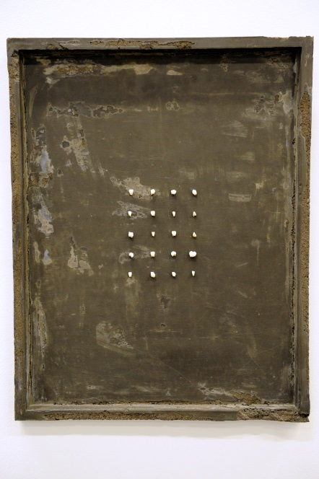

Fig.12: *The Tooth Fairy Collection (four by five),*

(2015)

Ricardo Pimentel

The viewer is presented with a ‘picture’ with the solid frame cast from concrete. On the frame are twenty milk teeth arranged in a 4 × 5 rectangular array. This work is more akin to Sierra’s piece ‘*24 Blocks of concrete constantly moved during a day's work by paid workers*’ rather than Gonzalez-Torres’ work “*Untitled*” *(Portrait of Ross in L.A)*. There is no physical interaction between the piece and the viewer, the removal of the teeth from the child has already occurred and what is presented is purely the result of that action. Although displayed in a conventional form, fulfilling many of the criteria of a gallery hanging, I would argue that this work does not fall purely into the category of art as cultural object. The viewer is unlikely to remain as a passive spectator. Jean-François Lyotard presents the argument that for some artwork the “work is not merely a cultural object, although it is that too. It harbours within it an excess, a rapture, a potential of associations that overflows all the determinations of its reception and production” (1991, p.1136). Here Lyotard was alluding to the influence of the affect on the viewer or its power in an immanent sense. The use of milk teeth is a deliberately emotive ploy as they potentially come with the burden linked to the viewer’s childhood and relationship with their parents. It is therefore not a piece to be considered solely on its aesthetic as there are other forces at play. The losing of milk teeth along with a child’s first day at school, first period and first sexual encounter are often considered milestones in the life of a child/adolescent. The losing of teeth also comes accompanied with the tension between pain, anticipation and pleasure. The siting of the teeth within a concrete frame is important also. There is an element of decay about the frame and the teeth are also positioned in such a way as to suggest a deliberate act. Were they all removed at the same time? Are these medical specimens laid out for inspection? The absence of the rest of the body with which to site the conditions in which the teeth were removed reinforces the central argument that absence can serve to accentuate a presence. The work therefore has an affective aesthetic that cannot be fully controlled by me, the artist and carries a significance beyond the object itself.

Conclusion

In Michael Fried’s Art and Objecthood (1967), he outlined his suspicion of critics that view artwork within a historical or cultural context rather than as an artwork on its own terms. In particular he was wary of critics’ inability to differentiate between the artwork itself and the experience of viewing it, something he termed ‘theatricality’. “Whereas in previous art what is to be had from the work is located strictly within it, the experience of literalist art is of an object *in a situation* – one that, virtually by definition, *includes the beholder*” (*ibid,* p.839). Since then, ‘theatricality’, or as Bourriaud coins ‘relational aesthetics’ (2002), in which the theatricality, by way of intersubjective discourse is key and an understanding of the artwork’s historical and cultural context central, has become a dominant art form. “Unlike an object that is closed in on itself by the intervention of a style and a signature, present day art shows that form only exists in the encounter and in the dynamic relationship enjoyed by an artistic proposition with other formations, artistic or otherwise” (*ibid*, p.21)

This essay has focussed on how the body is used in contemporary art to engender that discourse between artist and viewer. In that respect it distances itself from the ideology proposed by Fried and aligns itself with the significance and potential of the relational encounter for contemporary art. However there is also a recognition, as identified by both Kenning (2009) and Bishop (2004), that as these encounters generally occur within the network of art institutions of one form or another, that Bourriaud’s claim to a fully democratic discourse is perhaps overstated.

Consciously it has steered away from cases in which the body is actually present. This essay has presented the case that the physical presence of the body is not necessary and that its presence through its absence, or its alluded form, can in fact be as powerful a tool, if not more so when used insightfully.

The four works considered (two of which are my own) present the absence of the body in different ways. What unifies them however, is that each deliberately create conditions for intersubjective encounters. The acknowledgement of an audience and the rejection of their passivity is core to their approach and core to the emotional discourse. The absence of a body, the artist’s or otherwise, only amplifies this discourse.

Notes:

1. *The Dinner Party* consists of a large ceremonial banquet arranged on a triangular table with thirty-nine place settings. Each of the place settings honours a woman of significant historical importance. A further 999 famous women are commemorated on the floor tiles beneath the table.

2. In the *Untitled Film Stills* series Sherman photographed herself , dressed up, in poses and in locations reminiscent of film stills. These fictitious scenarios served to reinforce the notion that in a contemporary society, where imagery is a dominant medium, a person’s identity is a manufactured commodity.

3. In the case of “Untitled” (Perfect Lovers), the synchronicity of the two clocks alludes to the harmony between two lovers. The physical body itself is of secondary importance.

4. The viewer is presented with a wall on which are hung five hinged wooden flip-boards labelled ‘Exhibit 1’, ‘Exhibit 2’ etc. (Fig.14) the labelling serves as an invitation to view the images currently hidden within the flip-boards. The images, when viewed, are a montage of graphic photographs of the facial wounds of some of the soldiers treated by Dr. Gillies on which are superimposed photographs of contemporary commercial products (e.g. toothpaste, soap etc) (Fig:15).

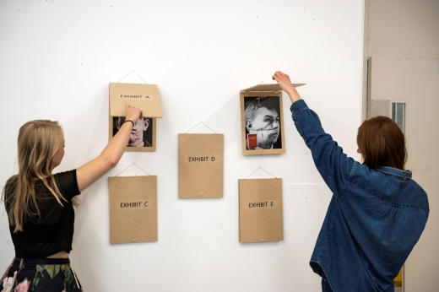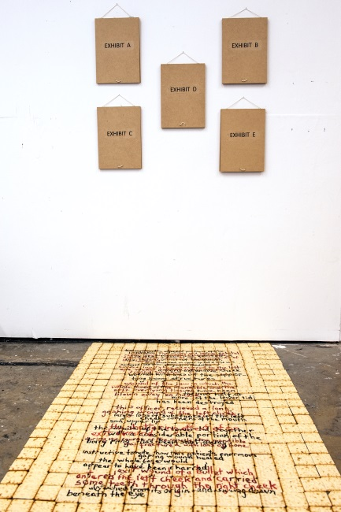

Fig.14: *The Sensational Case of*

*Dr. Gillies,* (2014)

Ricardo Pimentel

Fig.15: *The Sensational Case of*

*Dr. Gillies (Detail),* (2014)

Ricardo Pimentel

References

Barthes, R. (1968). *The Death of the Author.* In: C.Bishop, ed. 2006. *Participation.* London:

Whitechapel Gallery. p.41-45.

Bishop, C. (2004). Antagonism and relational aesthetics. October, 110(Fall), p.51-79.

Bishop, C. (2012). *Artificial hells: participatory art and the politics of spectatorship.*

London: Verso Books.

Bourriaud, Nicolas, et al. (2002). *Relational aesthetics*. Paris: Les presses du reel.

Debord, G. (2010). *The society of the spectacle*. Detroit: Black & Red

Doyle, J. (2013). *Hold it against me. Difficulty and emotion in contemporary art.* Durham:

Duke University Press

Fried, M. (1967). *Art and Objecthood.* In: C.Harrison & P.Wood, ed. 2002. *Art in Theory,*

*1900-2000, An Anthology of Changing Ideas.* Oxford: Blackwell Publishing. p.835-846

Gillies, H. D. (1920). *Plastic Surgery of the Face: Based on Selected Cases of War Injuries of the*

*Face*. London: Henry Frowde.

Greenberg, C. (1939). Avantgarde and Kitsch, *Partisan Review,* Volume 6(5), p.34-49.

Jones, J. (2014). History and all its grisly facts are worth more than the illusion of memory.

*Guardian Online*, [online] 31 October. Available at:

<http://www.theguardian.com/commentisfree/2014/oct/31/world-war-one-poppies-memorial-cameron> [Accessed 17 September 2015].

Kafka, F. (1916). *Metamorphosis and Other Stories.* Translated by W.Muir & E.Muir.,1990.

Ayelsbury: Penguin Books.

Kenning, D. (2009). Art Relations and the Presence of Absence. *Third Text*, Volume 23(4),

p.435-446

Lyotard, J-F. (1982). *What is Postmodernism?.* In: C.Harrison & P.Wood, ed. 2002. *Art in*

*Theory, 1900-2000, An Anthology of Changing Ideas.* Oxford: Blackwell Publishing.

p.1131-1137

Martin, S. (2007). Critique of Relational Aesthetics. *Third Text*, Volume 21(4), p.369-386.

O'Reilly, S. (2009). *The body in contemporary art*. London: Thames & Hudson.

Owen, W., 1917. Anthem for Doomed Youth. In J. Stallworthy, ed. (1994). *The War Poems*

*of Wilfred Owen*. London:Random House

Rosero, A. (2013). Locating work in Santiago Sierra’s artistic practice. *Ephemera. Theory &*

*Politics in Organization,* Volume 13(1), p.99-115

Sainsbury’s. (2014). Sainsbury’s Official Christmas 2014 Ad. [online] Available at:

<https://www.youtube.com/results?search_query=sainsburys+advert+2014>

[Accessed 6 January 2016]

Sontag, S. (2003). *Regarding the Pain of Others.* St.Ives: Penguin.

Sontag, S. (2009). *Against Interpretation and Other Essays*. St.Ives: Penguin.